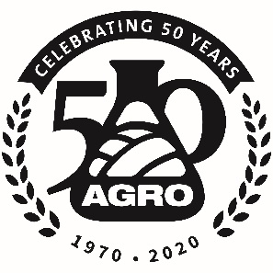 | Call for Papers  264th ACS National Meeting & Exposition  August 21 – 25, 2022  Chicago, Illinois USA

Title of Symposium – 100 characters including spaces
DELETE THIS BOX BEFORE YOU SUBMIT YOUR SYMPOSIUM PROPOSAL
- Please do not change the layout, fonts, spacing, or margins
- Title – Be succinct – 100 characters including spaces
  - The purpose of the title is to draw in submitters, casual attendees and those really interested in your topic, and even the press (especially if it is topical).
  - You can add subtitles later to separate your sessions
  - Avoid these words: Advances, Innovation, Novel, etc.

Purpose of Symposium

In 150 – 200 words, describe what your scientific outcomes of the symposium will be. Who will you want to attend your symposium? Why should they? You may also have policy issues that need to be discussed. What are the international issues/perspectives? What do your customers need? Are there other organizations or ACS Divisions that might be interested, such as, ANYL, ENVR, ORGN, or AGFD?

If this is an Early Career Symposium, include that the goal is to provide a platform for postdoctoral and early career scientists to present their latest research results and serve as a platform to foster future collaborations.

This should be one or two paragraphs, i.e., prose.
Suggested Topics

- Make a list of 5 to no-more-than 10 topic areas that people might want to consider
- Remember your non-research scientists, policy people, customers might be interested in presenting to give your symposium focus and relevance
- Present these as bullets of 6 to no-more-than 25 words.
- Watch your bullet construction – start each bullet with a noun (or a nominative phrase) or an action verb, but try not to mix and match
- The total word allowance here is 200 words

For further information, contact the organizers
Name, affiliation, phone, email << DO NOT INCLUDE TITLES
List the primary first (if there is one) then list the others in alphabetical order
Joe Cool, Real Smart People University, 999-999-9999, joecool@rspu.edu
Jill Smith, US Gov't Agency, 999-999-9999, jill.smith@agency.gov
Jackie Wilson, Crop Protection Company, 999-999-999, jackie.wilson@cpc.com

Submit abstracts of 2500 characters or less to
http://maps.acs.org
January 6 – March 30, 2022 << this may change

SUMMARY OF SYMPOSIUM FOR MAPS – 50 words or less

